**Objective: Front-End Developer**

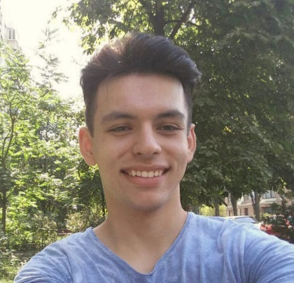

Personal information: Vladyslav Yudashkin

Date of Birth: 19.05.1997

Residence : Kyiv

Contact information: **https://valedus.github.io**

**phone number: (063) 929-81-07; email:** [**valedus97@gmail.com**](mailto:valedus97@gmail.com)

**Personal qualities: •**Punctual

•Communicative

•Disciplined

•Responsible

•Passionate

•Purposeful

•Without bad habits

**Skills:** Expert: Intermediate: Familiar/Learning:

HTML5/CSS3 C#, Unity3D PHP

Bootstrap 4 SASS Node.js

JavaScript JSON

JQuery Git

Photoshop

WordPress

Gulp

**Principles I follow:** DRY; BEM; Mobile First.

**Experience:** I used to develop games with C# on Unity3D. I decided to become proficient in web-development since I had experience with it in highschool (second place at city Olympics). Currently I'm rapidly learning new technologies and obtaining new skills, and have certificates and projects, which can confirm my knowledge.

**Languages:** English (conversational)

Hebrew (beginner)

**Education:** Incomplete higher education (National Aviation University);

Technological college ORT (Kyiv)

**Hobbies:** ThaiBoxing, Mnemonics (art of memorizing), Go (Chinese chess).